Step 1: Visit Oracle HomePage and download the zip file.

[https://www.oracle.com/in/database/free/get-started/#windows](https://www.oracle.com/in/database/free/get-started/%23windows)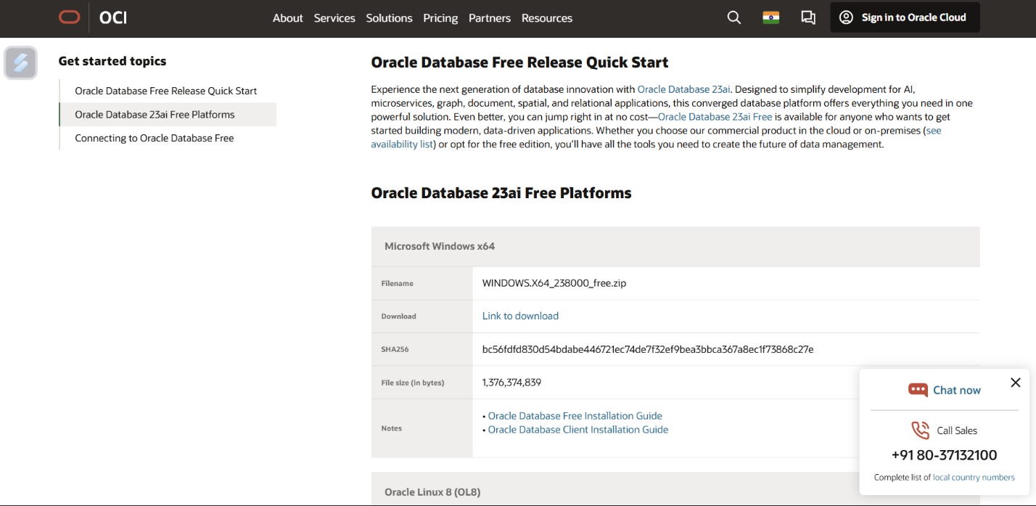

Step 2: Extract the zip file

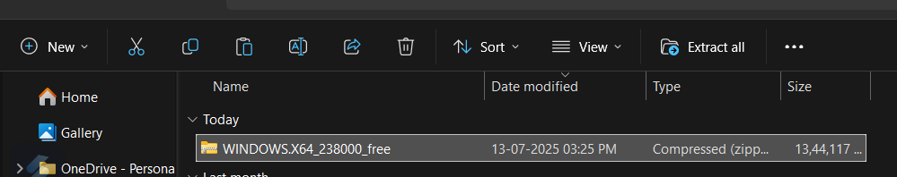

Step 3: Open Setup via Run As Administrator

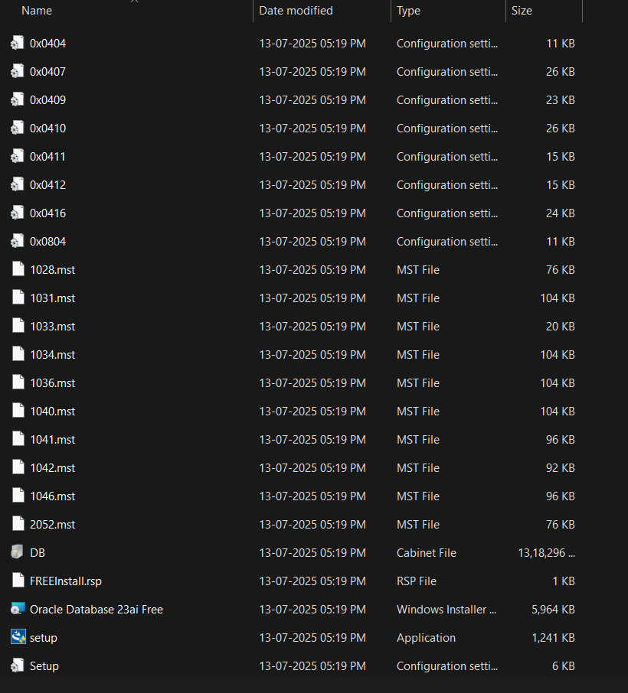

Step 4: Click on Next.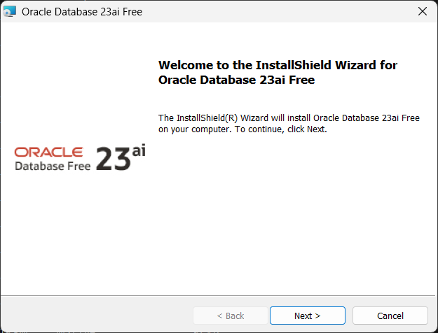

Step 5: Accept the terms and Proceed.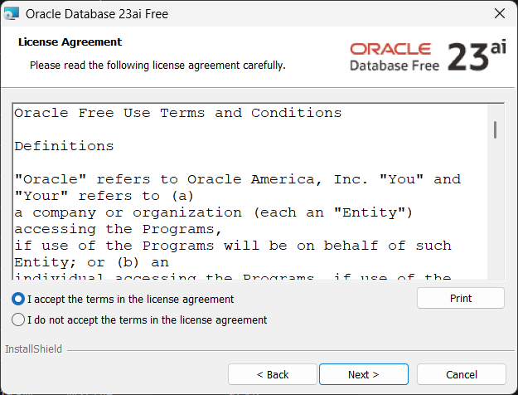

Step 6: Click Next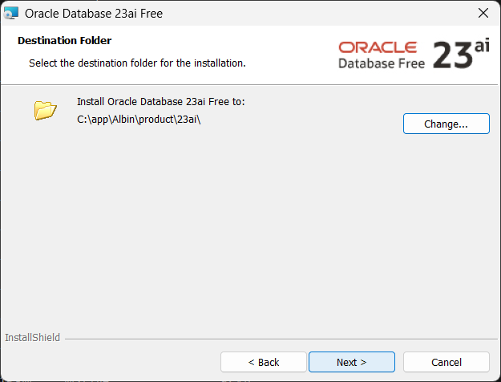

Step 7: Set a Password for the Database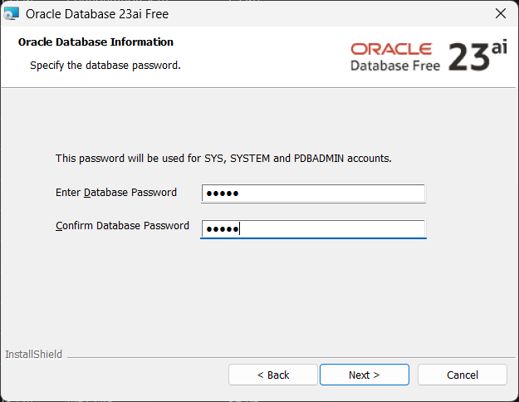

Step 8 : Click on Install.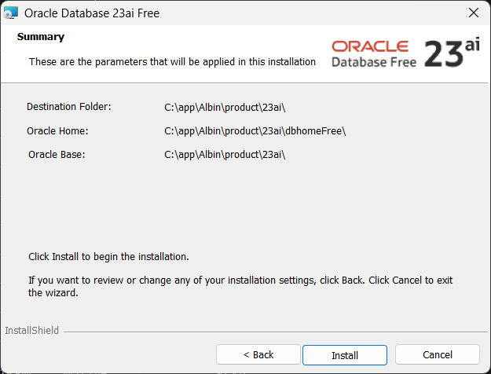

Step 9: Wait till it finishes.

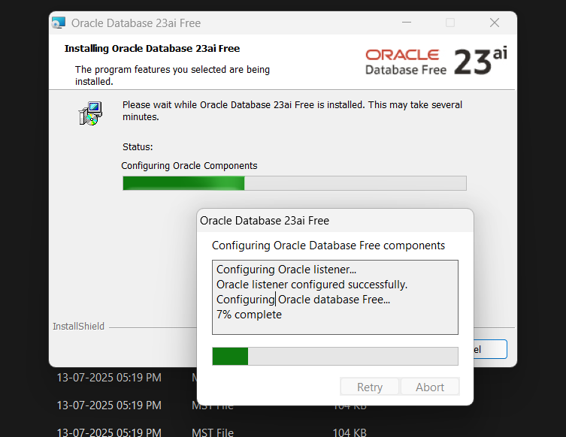

Step 10: You have successfully installed Oracle Database Fee 23ai.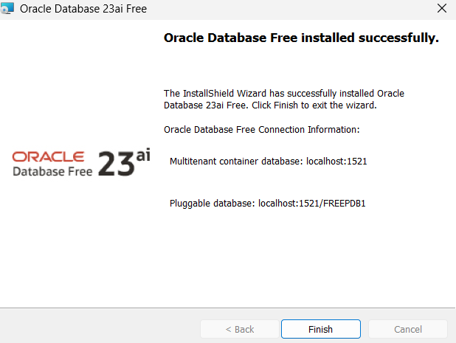

TO CHECK IF CONNECTED

